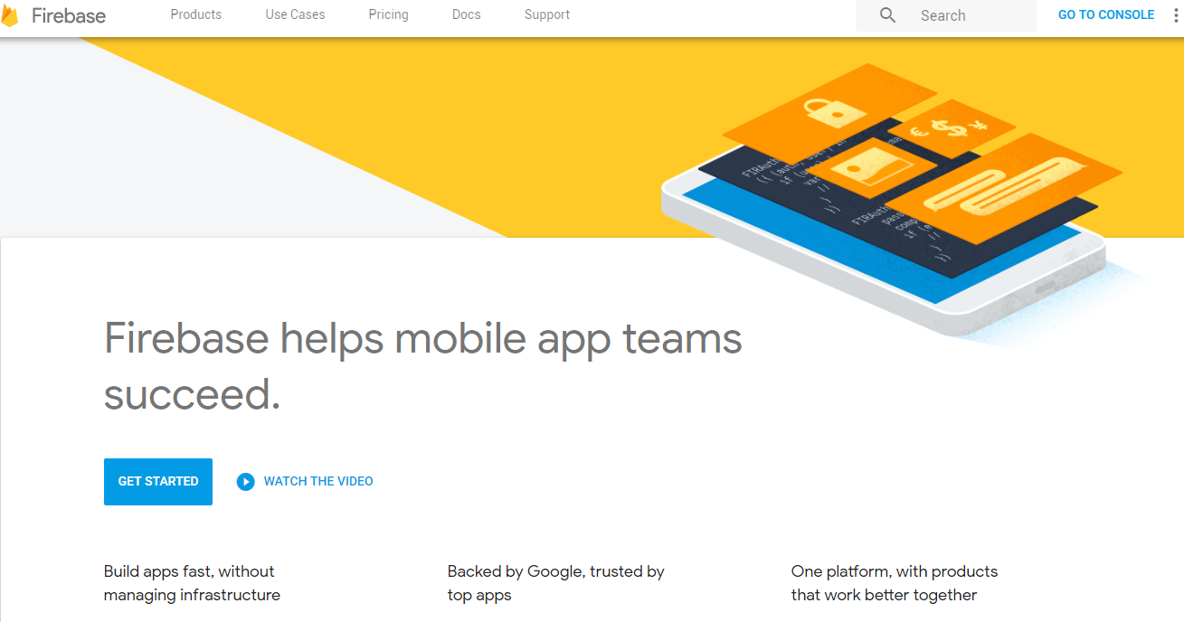

SIMPLE CHAT

The goal of this project is to demonstrate your ability to quickly learn new concepts and show your understanding of Swift. In this project you will build a simple chat app with a login / signup page.

Google’s Firebase is used widely across many apps as a basic backend. You should use Firebase to handle the chat capabilities of the app and Facebook’s Account Kit to manage the login / signup process. UI should be storyboarded (versus hard-coded) wherever possible. Be sure to comment and markup your code so it can be understood.

Required Features:

1. Ability to send chat messages between two accounts
2. Ability to send audio messages between two accounts
3. Ability to send picture messages between two accounts

Pages:

1. Login / Signup. Use Facebook Account Kit (you can sign up for a free Facebook Developer Account if you don’t already have one). Collect the new user’s phone number and name, this will be displayed on the Settings page. You can verify the phone number through Account Kit. You should be able to login using only the phone number by sending a verification text using Facebook Account Kit.
   1. Signup pages: Phone number, Verify number, Full name
2. Main page. Shows people you are chatting with.
3. Chat. This is the page in which you chat with each person. Similar to iMessage, you should be able to send pictures, chats, and short audio messages.
4. Settings. Show the person’s name and phone number that you collected during the signup process.

Font:

Helvetica

Feel free to add your own touch to the project, make it unique.

If you have any questions, feel free to ask.

Best of luck!